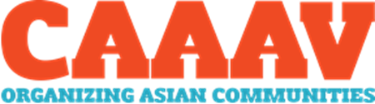
ASIAN YOUTH IN ACTION!
WHAT IS CAAAV?
CAAAV Organizing Asian Communities is a community-based organization that builds the power of low-income Asian immigrants and refugees to fight for racial, gender, and economic justice. CAAAV has two programs, Asian Youth in Action and our citywide housing organizing project.
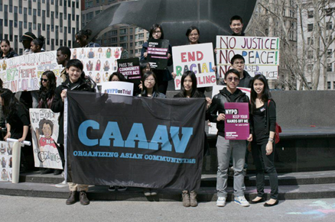
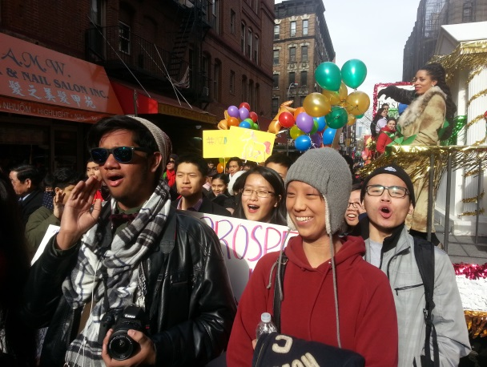
WHY SHOULD I JOIN?
You will:
• deepen your awareness about issues affecting low-income Asian communities;
• lead campaigns that build power among Asian immigrants and refugees;
• develop leadership skills through workshops and facilitation;
• travel to other cities and meet other youth;
• organize and participate in different community activities and events;
Youth members are provided MetroCards to attend programming & actions and lunch on Saturdays. Community Service letters also provided.

WHAT IS AYA?
Asian Youth in Action develops the leadership of youth ages 14-20 in New York City to engage their communities for social change. Currently, the program is participating in a campaign against police violence. We have conducted Know Your Rights trainings concerning interactions with the NYPD, produced a short documentary about the impact police harassment has on Asian communities, spoken to elected officials, organized an art and history exhibit, participated in city-wide rallies, marches, press conferences, and much more…
Our work has already brought change for our communities! Through our participation in the campaign Communities United for Police Reform, we were victorious in supporting City Council to pass the Community Safety Act, which bans discriminatory profiling by the NYPD!

________________________________________________Applications due Friday, June 6, and available on the next page or at: http://caaav.org/asianyouthinaction.

WHEN DOES AYA MEET?
Summer (July/Aug): Tuesdays and Thursdays (1-4PM), and Saturdays (12-4PM).
School Year: Saturdays (12-4PM).
Youth can further develop leadership and experience by attending events outside of the meeting times or volunteering for leadership opportunities.
HOW DO I APPLY?
Name: ____________________________ Date of Birth:_____________________
Address: _________________________ Phone:_____________________________ Email:_____________________________ Gender:____________________________
Ethnicity:_________________________ Language(s):_____________________ School:____________________________ Grade:_____________________________
TELL US ABOUT YOURSELF (recommended one paragraph per question)
1. What are your interests? Who do you look up to?
2. Please describe any community-based work experience you have.
3. Describe one issue that affects Asian youth in NYC that you care about? Why do you care about this issue?
4. Why are you interested in applying to Asian Youth in Action?

Additional Questions:
Are you available on the days AYA meets (during the summer and the school year)? Are there other commitments that would interfere with your ability to be fully present at AYA?

Have you ever been harassed or treated unjustly by the NYPD?

Email to asianyouthinaction@gmail.com (online application at caaav.org/asianyouthinaction)
OR bring it to our office at 55 Hester Street, New York, NY 10002 by June 6, 2014!
If you have any questions, email Ruben An at ran@caaav.org or call our office (212)473-6485.

